**Git Project**

Git init: Creates new git repository



Git add: Adds a change in the working are

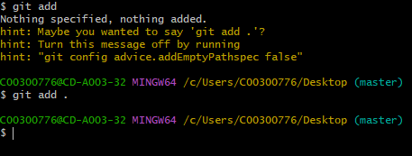

Git status: Displays state of working area

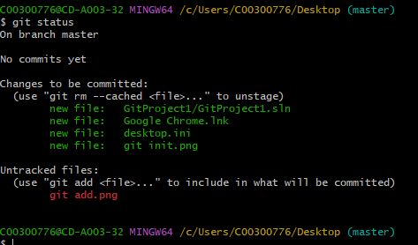

Git Commit: Required to select changes for next commit

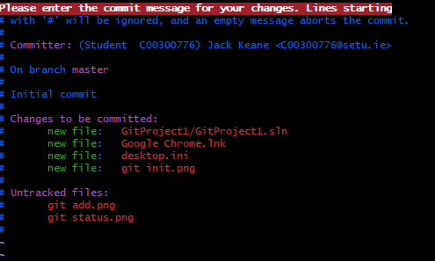

Git remote: Serves as a bookmark

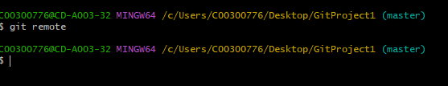

Git Push: To upload from local to remote repository

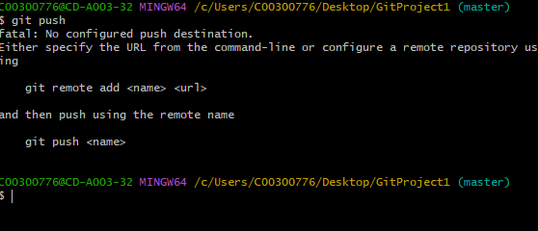

Git Checkout: To navigate branches



Git merge: Combines commits



Git log: Displays all previous commits



Git clone: Copies a repository

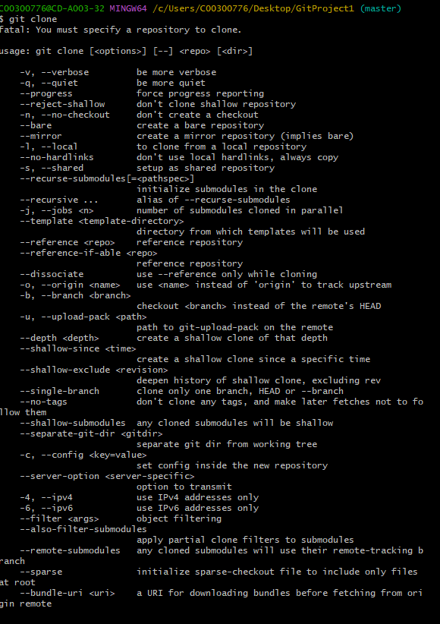

Git pull: To fetch from remote repository

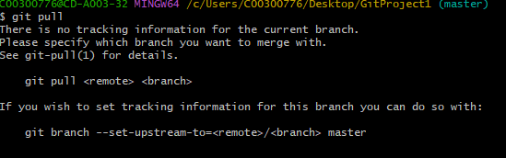

Git stash: Shelves the data so you can return later

